INITBAKE PROJECT SETUP

- Create a folder initbake workspace on D

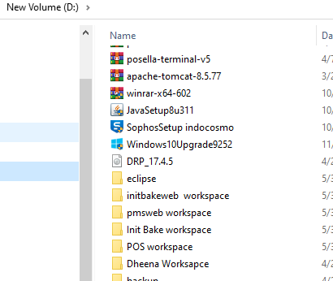

- Then download the project from the Github

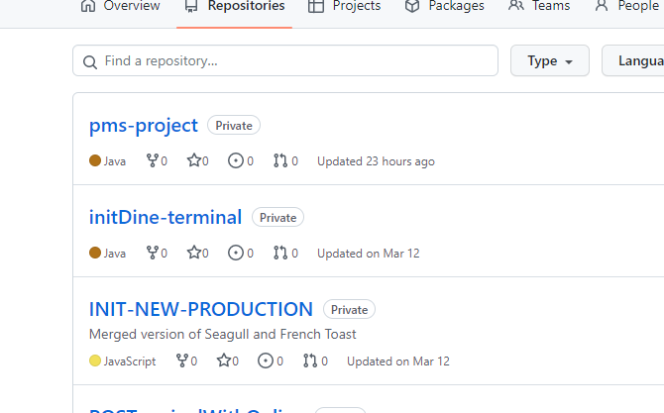

- Download and Extract to “initbake workspace”.

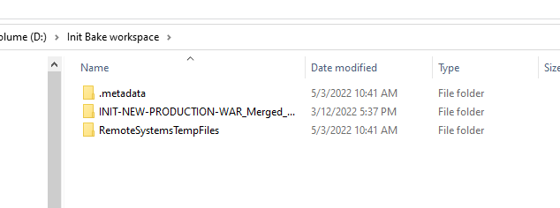

- Open Eclipse with “initbake workspace” then import using file--->import--->add exsisting project-->browse location and finish.

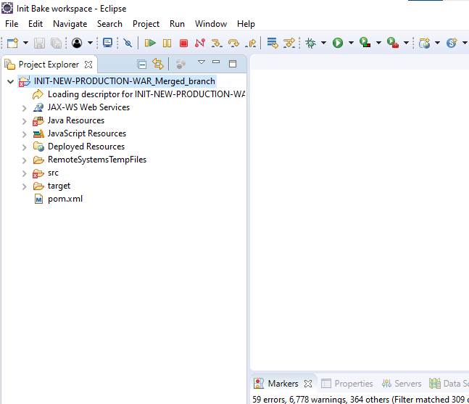

- DB setup
  - Select src-->main-->resources and open the database.properties file.
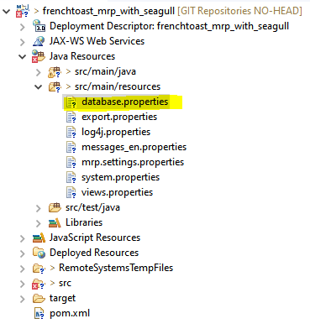

  - Give correct DB details

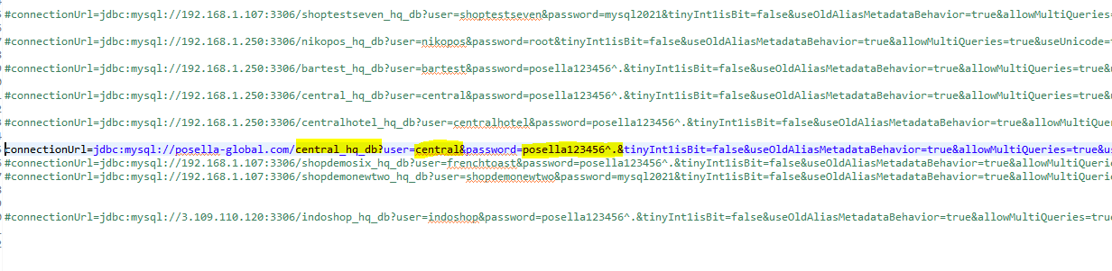
  - Save the file

- For Run the project Generate a War file using Right click on the Project--> EXPORT--->WAR file

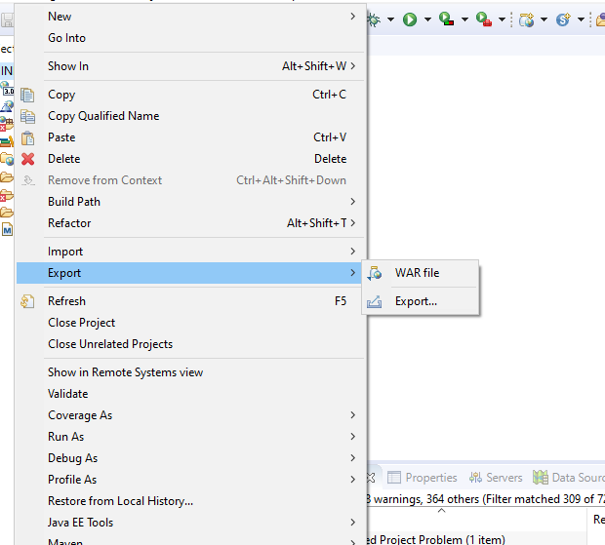

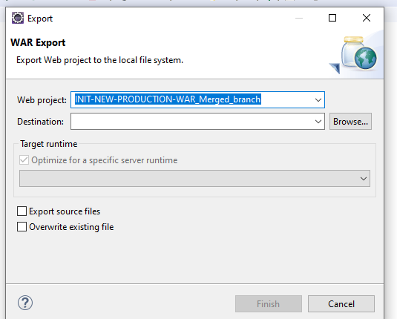

Then choose location as “D:\apache-tomcat-8.5.78\webapps””

- Then start Tomcat or open Tomcat start batch file from bin folder of apache tomcat

- Then checks D:\apache-tomcat-8.5.78\webapps,,there should be a “initbake” folder

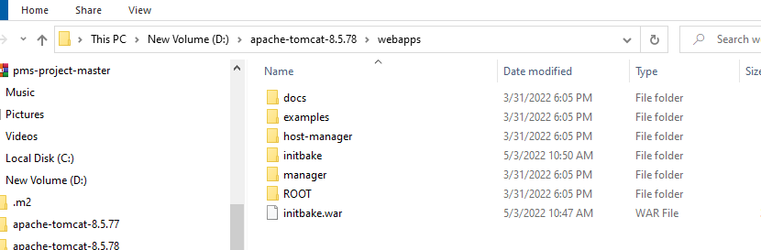

- then inside the chrome “localhost:8082/initbake

